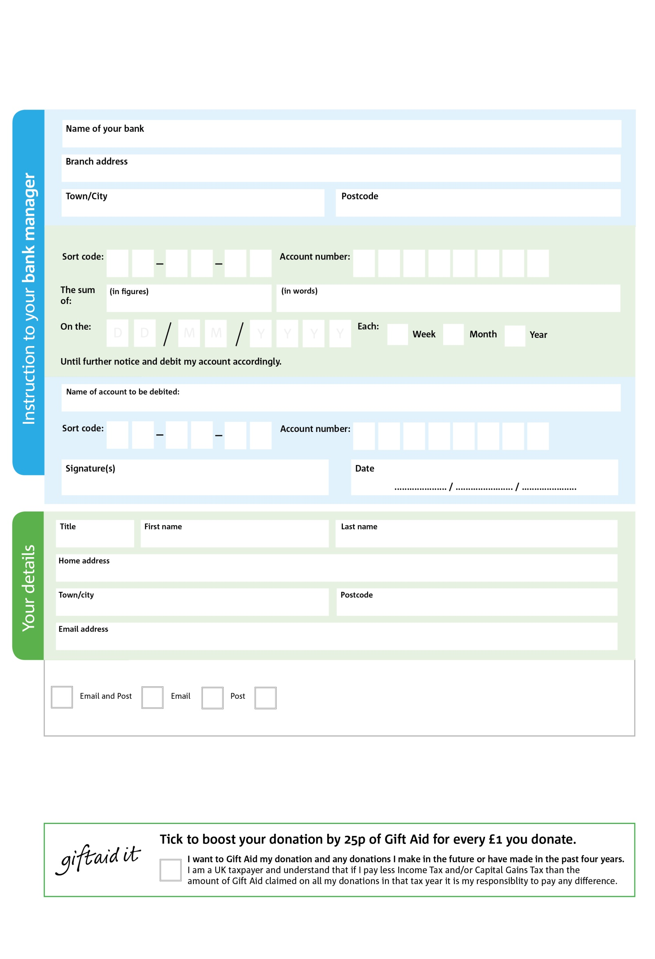

**Please pass this form onto the foodbank, using the foodbank’s address at the bottom, who will save a copy for their records. They will then send it onto your named bank or building society.**

**Data protection**

Llandrindod Foodbank is committed to protecting your privacy and will process your personal data in accordance with the Data Protection Act 1998. Llandrindod Foodbank collects information to keep in touch with you and supply you with information relating to our work. Llandrindod Foodbank will never sell or pass your details to anyone who isn’t directly working on our behalf.

Office Address: Oasis, Spa Road, Llandrindod, LD1 5ER

**Standing Order Mandate**

**Llandrindod.foodbank.org.uk**

5

V

4

V

4

V

3

V

2

V

7

V

3

V

7

V

8

6

8

9

0

2

We would love to keep you up to date with information about Llandrindod Foodbank. Please tick your preference:

You can change your preferences any time by contacting us on 07519 839 189 or emailing us at info@llandrindod.foodbank.org.uk

I do not wish to receive future communications from Llandrindod Foodbank

Please pay Llandrindod Foodbank

Reg. Charity No: 1174880 | Reg. in England & Wales

You can change your preferences any time by contacting us on XXXXXXXXXXX or emailing us at XXXX@XXXXXXXXXX.foodbank.org.uk

I do not wish to receive future communications from XXXXXX Foodbank